1. **Create a shell script to print the HTTP error code of guvi.in & print, the success/failure message based on the error code response**

**nano http_status.sh**

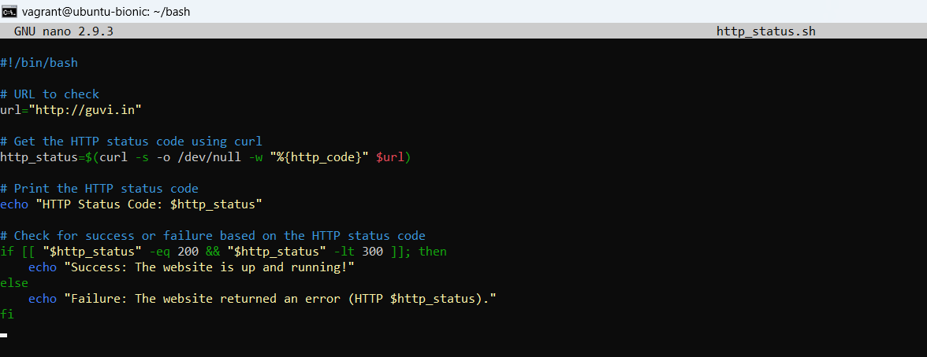

**Code:**

**#!/bin/bash**

**# URL to check**

**url="http://guvi.in"**

**# Get the HTTP status code using curl**

**http_status=$(curl -s -o /dev/null -w "%{http_code}" $url)**

**# Print the HTTP status code**

**echo "HTTP Status Code: $http_status"**

**# Check for success or failure based on the HTTP status code**

**if [[ "$http_status" -eq 200 && "$http_status" -lt 300 ]]; then**

**echo "Success: The website is up and running!"**

**else**

**echo "Failure: The website returned an error (HTTP $http_status)."**

**fi**

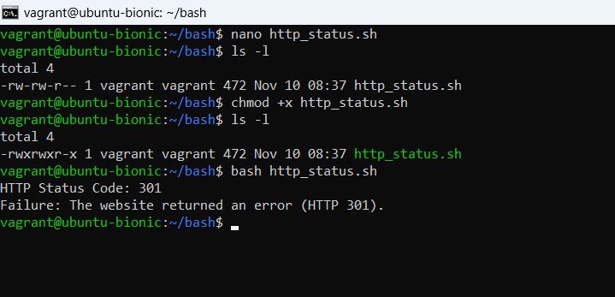

1. Given a file, replace all occurrence of the word "give" with "learning" from 5th line till the end in only those lines that contain the word "welcome"

Input file : file.txt

output file : output.txt

**Bash script file**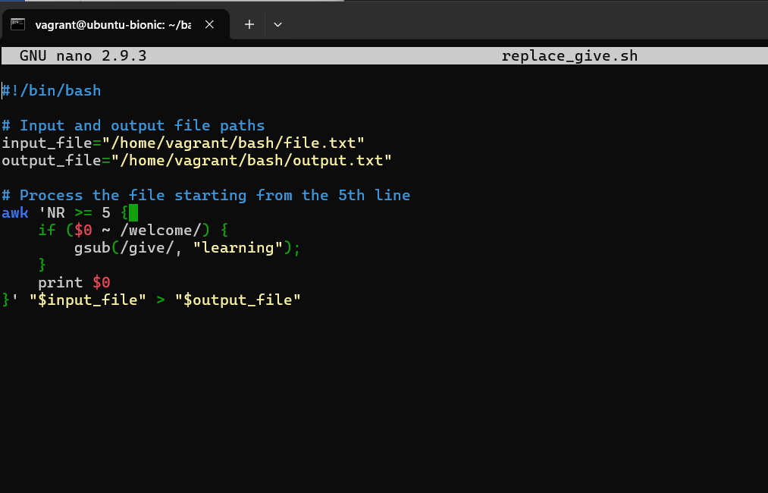

**Input file**

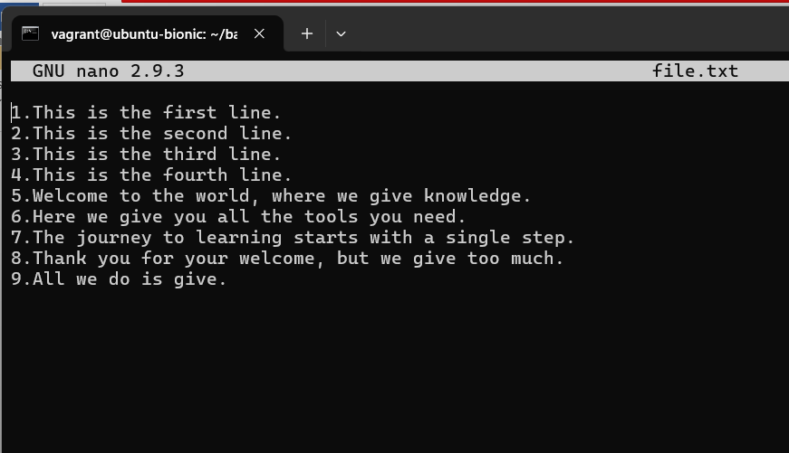

**Output file**

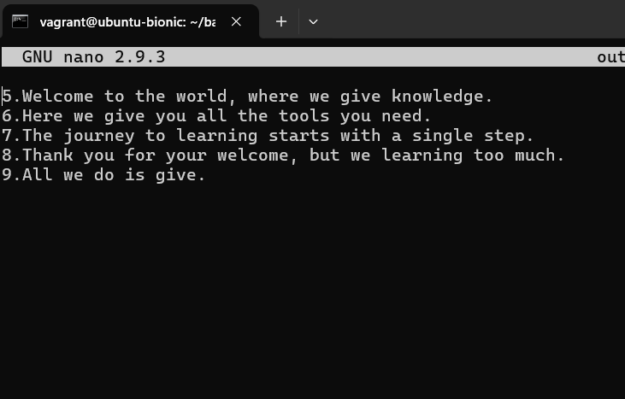

**Main**

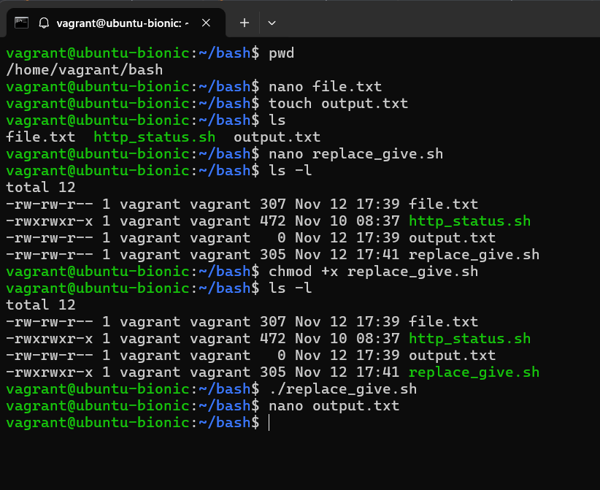

**Output 2**

**Script file – replace word same file**

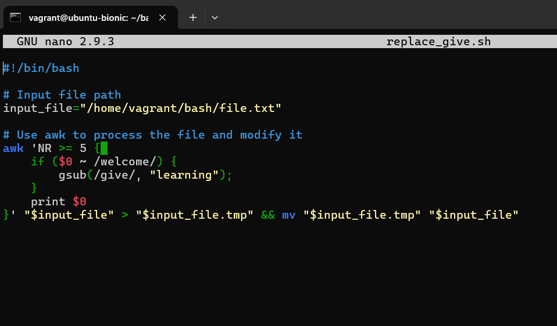

**Input**

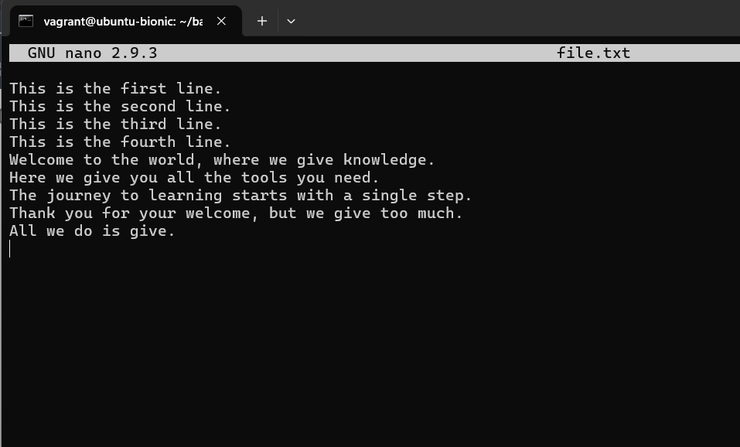

**Output**

